Jeff Linn  
C856 User Experience Design  
Performance Assessment, Task 1

Scenario:

Redesign the existing tourism website. The page navigation is unclear. All the tourist information is jumbled together on a single page, and the site lacks booking information and links to each activity or option. The site is also not compatible with mobile devices. Complete it in 30 days.

Business Goals as outlined in the Scenario:

1. Increase tourism to the country and its attractions
2. Provide welcoming experience for prospective tourists
3. Spend no more than 30 days to redesign website solution

Timeline:

The project timeline includes each of the UX design activities and outlines the estimated time frames for each step in the process. The project timeline fits within the project time frame given in the scenario.

Activities to cover: 1) Business requirements, 2) user requirements, 3) website design.

1. Stakeholder Interviews to gather information about business requirements over the phone or internet from a distance. 2 Days.
2. Benchmark Usability Test of existing website to gather pain points from Users. 2 Days.
3. Consolidate preliminary data from stakeholders and usability test for reporting a baseline. 1 Day.
4. Kickoff Meeting in person to get on the same page, review preliminary findings and requirements, as well as confirming the plan of activities to succeed. 1 Day.
5. Since the Client has already provided research results, utilize the Survey and About the Island docs to generate a Persona Profile. 1 Day. (Name, Picture, Bio, Behaviors, Needs, Goals).
6. Create an Information Architecture. 3 Days. organize and structure the content into a sitemap
7. Develop Sketches of website solution based on IA. 3 Days.
8. Create low fidelity Wireframe based on final sketches. 4 Days.
9. Develop a prototype interactive website. 5 Days.
10. Conduct guerilla Usability Testing with 3 user testers. 1 Day.
11. Summarize the qualitative feedback. 1 Day.
12. Modify Prototype based on feedback from Usability Testing. 3 Days.
13. Conduct guerilla Usability Testing. 1 Day.
14. Modify Prototype based on additional feedback. 2 Days.
15. Submit website prototype as URL weblink with list 5 objective Usability Tasks for prototype usability in Task 2

Persona Profiles :

Tim (34) and Steph (28) McKeever – newly-weds from California, USA making about $100k per year together (both as nurses) will be renting a beach house for 5 days on their first visit to the island on honeymoon. They traveled by air, rented a car and are interested in island attractions. They‘ll spend time relaxing on the beach and go out to nice dinners. They plan to rent a car to visit the volcano and go to the brewery afterwards. 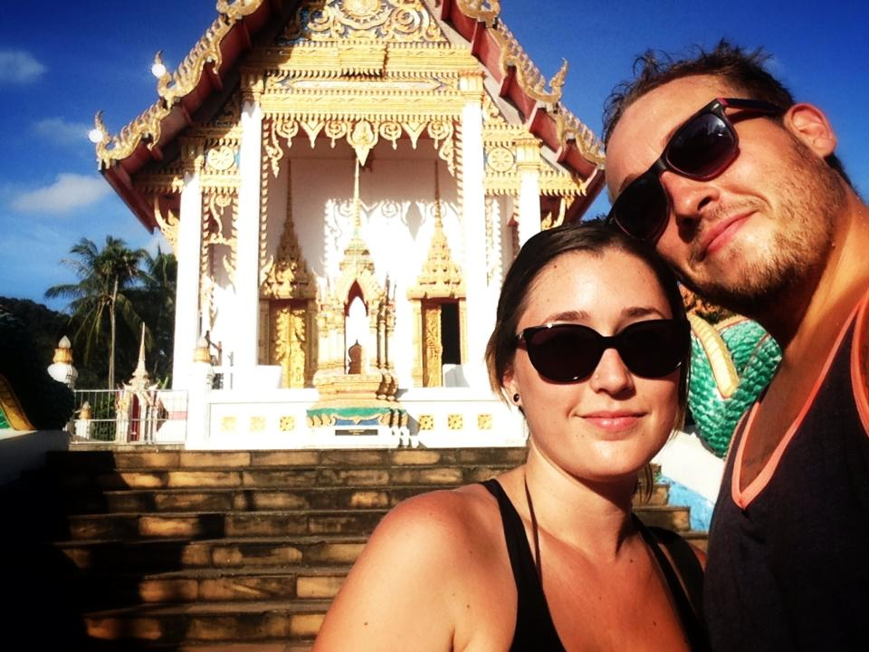

Hahn Family from Virginia, USA making $65k per year (Dad owns a local flooring business) will come to the island via cruise ship and stay at a hotel for 7 days. This is their first trip to the island, they’ll rent a car to visit the rainforest for zip lining together, relax on the beach. When Dad goes golfing, Mom and two teen daughters will rent bikes to tour the town. 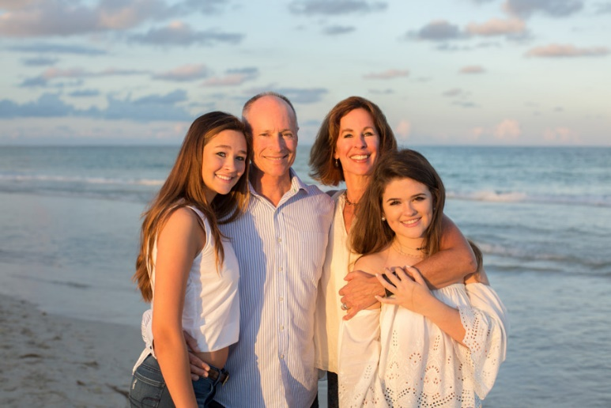

The Kirkby family of 5 from Canada, making $75k per year (Mom is a real estate agent, Dad stays at home), traveling by air to visit the island for the first time. Staying for 7 days at a hotel, planning to enjoy the snorkeling, playing at the arcade, and bowling. They’ll rent a car and use public transport since the kids are too young to ride bikes.

Resources:

“About the Island” C856 HJP2 Task 1 Supporting Documents

“Data Survey Results: *HJP2: Project Approach and Prototype*” C856 HJP2 Task 1 Supporting Documents

“McKeever Couple” image credit: <https://www.samuitimes.com/wp-content/uploads/2013/11/USA-couple.jpg>

“Kirkby Family” image credit: <http://blissfullydomestic.com/wp-content/uploads/2013/10/Family-Photo-Tips-102.jpg>

“Hahn Family” image credit: <https://tovaphotography.com/wp-content/uploads/2018/03/miami-sunset-family-session-001.jpg>

WIREFRAME SNAPSHOT (Online InVision link below):

https://projects.invisionapp.com/prototype/ckv10xysb000hp301p2w9g5dj/play

SUMMARY OF USABILITY TESTING WITH 3 USERS:

Feedback 1:

* Incorporate a heading above the content section to help describe the content.
* Insert a “Live Chat” feature on the home page to provide assistance.
* Use more accessible language such as “getting here” and “getting around” instead of “Transportation.”
* Add a Museum tab and Brewery Tab, helicopter tours, art galleries on the side
* Provide a map of the island with locations of activities include link on FAQ

Feedback 2:

* They asked about potential payment plans or deals/specials
* What is the danger of the volcano?
* Is there wiFi on the island or places to do business?
* Incorporate a reservations button, link to flights/airport
* Does the island close down for holidays? Provide schedules

Feedback 3:

* Reduce the size of the tabs on the side, why are they so large?
* Change the font
* Homes on the beach aren’t mentioned in the content, why a side tab?
* Add a link to AirBnb and an activities page
* Make “not strictly enforced” in bold on the FAQ page

Actionable feedback:

* Insert headings above content, more relaxed accessible language, add additional tabs such as Museum/Tours. These will be implemented to make the website more user-friendly and navigable, as well as highlight the available amenities. Headings above the content will help identify where the user is within the site. More relaxed language will make the site more modern and updated in general, while providing the feel of relaxed vacation that customers want.
* Provide a map and link with location of activities, include more info about volcano safety. The map will help users visually see the island and where their amenities are geographically or where they might want to stay. It would help visitors plan their vacations better should they want to travel the island.
* Mention that WiFi exists on the island, Add a reservations button. WiFi will help boost appeal to visitors and should be mentioned that it does exist on the island. A reservations button/link will make it easier for potential visitors to book a hotel or rental home of their choosing and will help show that the island possesses multiple options.
* Add a link to the airport and flights, include island info on holiday schedules/closures. Since most of the island visitors fly to the island, it makes sense to include a link to the airport/flights within the website. Likewise, because the island has closures on some holidays, it’s important to provide a schedule of holidays for visitors to plan around accordingly.
* Reduce size of side tabs, change the font, add Airbnb link and Activities tab – these will be consolidated into the Staying Here and Playing Here pages. Updating the font will help make the website more modern, user-friendly, and accessible to potential visitors online. Reducing the size of some of the tabs will also make mobile versions of the site easier to view on phones/tablets. Links to the AirBnB website and activities will assist in the overall image of the available accommodations on the island.
* Make the “not strictly enforced” in bold on FAQ page. It will help emphasize this point. This is important for families vacationing with teenagers if they’re concerned about alcohol consumption and its availability and relaxed policies, which may be different from what some families are used to.
* Add a Let’s Chat feature. This will provide a modern update to the island website and help potential visitors quickly address any questions they may have by speaking directly with a representative of the island.

Non-Actionable feedback:

* Payment plans would not be something the island government would handle. Those would be made with individual companies or vendors. Therefore, this would not be a feature on the website.

Website Prototype URL: <https://linnj4.wixsite.com/website>

FIVE OBJECTIVE USABILITY TASKS FOR TASK 2

1) Plan a different island activity for each day of a 4 days vacation

2) Send a message to the Taniti website

3) Determine what will be open during Holidays

4) Rent a private condo

5) Make a dinner reservation